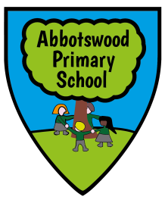





Next year I shall be continuing the responsibility of being the teacher representative on the ‘Friends of Abbotswood’ group. If your child is at Abbotswood Primary then you are automatically a Friend of Abbotswood, and I would welcome your ideas on how to create a group that will help and support both parents and pupils.
Mr Jelf
.


The aim of The Friends is to make our children’s education as rich and varied as possible by funding extra opportunities that are not covered by the school’s budget. We therefore hold a number of fundraising events throughout the year, including discos, fairs, Mother and Father’s day wraps, movie nights as well as Friday tuck shop and ice cream Fridays.
We need your help to run these events. If we do not have more support, it could mean that The Friends disband and the additional opportunities and funds are lost.


I have worked at Abbotswood for three years now and have loved every single minute of it! Our children are such a credit to the school and the community and I believe that they deserve a range of extra-curricular opportunities.


So far this year, The Friends have raised almost £1,500 for the school and this money has gone towards buying new forest school equipment, new reading books for the library, buses to take the children on school trips, an anti-bullying performance for the school and money towards a new football kit.
Our next target is to re-furnish all the classrooms in the school with new tables and chairs and some changes to the outdoor learning area in the Reception classes.

Our
Whilst The Friends are incredibly enthusiastic about this school and the potential that it has – we cannot do it alone. I am looking for a group of dedicated parents to join the team, help plan, and provide these opportunities.

If you have an interest in helping, either by becoming an active member of the group, or by helping run an after-school club then please contact the school at parents@abbotswoodprimary.org.uk and I will get back to you as quickly as possible.
We are here to support you, your children and your children’s school.
I look forward to working with you in what will be a very exciting year!

Mr. Jelf.



